Bug Tracking Tool

|  |  |
| --- | --- |
| **ID** | 1001 |
| **Name** | Home Page - Typos in title |
| **Priority** | P3 |
| **Steps to reproduce**:   1. Log into the system 2. Open Home page   **Expected results**:   * Title is equal to ‘Address Enrichment’   **Actual results**:   * Title is equal to ‘Addres Enrihment’   **Please take a look at the attached screenshot.** | |

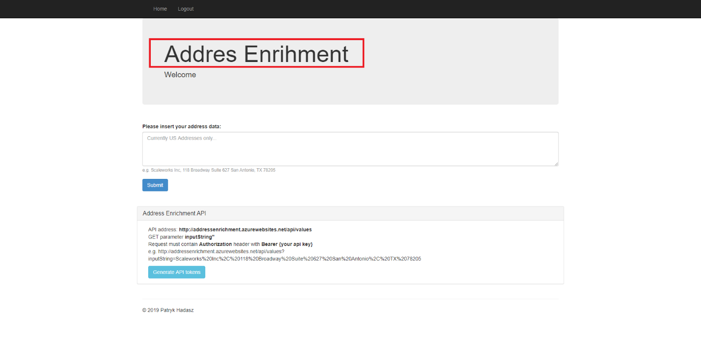

|  |  |
| --- | --- |
| **ID** | 1002 |
| **Name** | Home Page – no margin for Address Enrichment API area |
| **Priority** | P3 |
| **Steps to reproduce**:   1. Log into the system 2. Open Home Page   **Expected results**:   * Address Enrichment API area has margins as the rest of page   **Actual results**:   * Address Enrichment API area has no left and right margins   **Please take a look at the attached screenshot.** | |

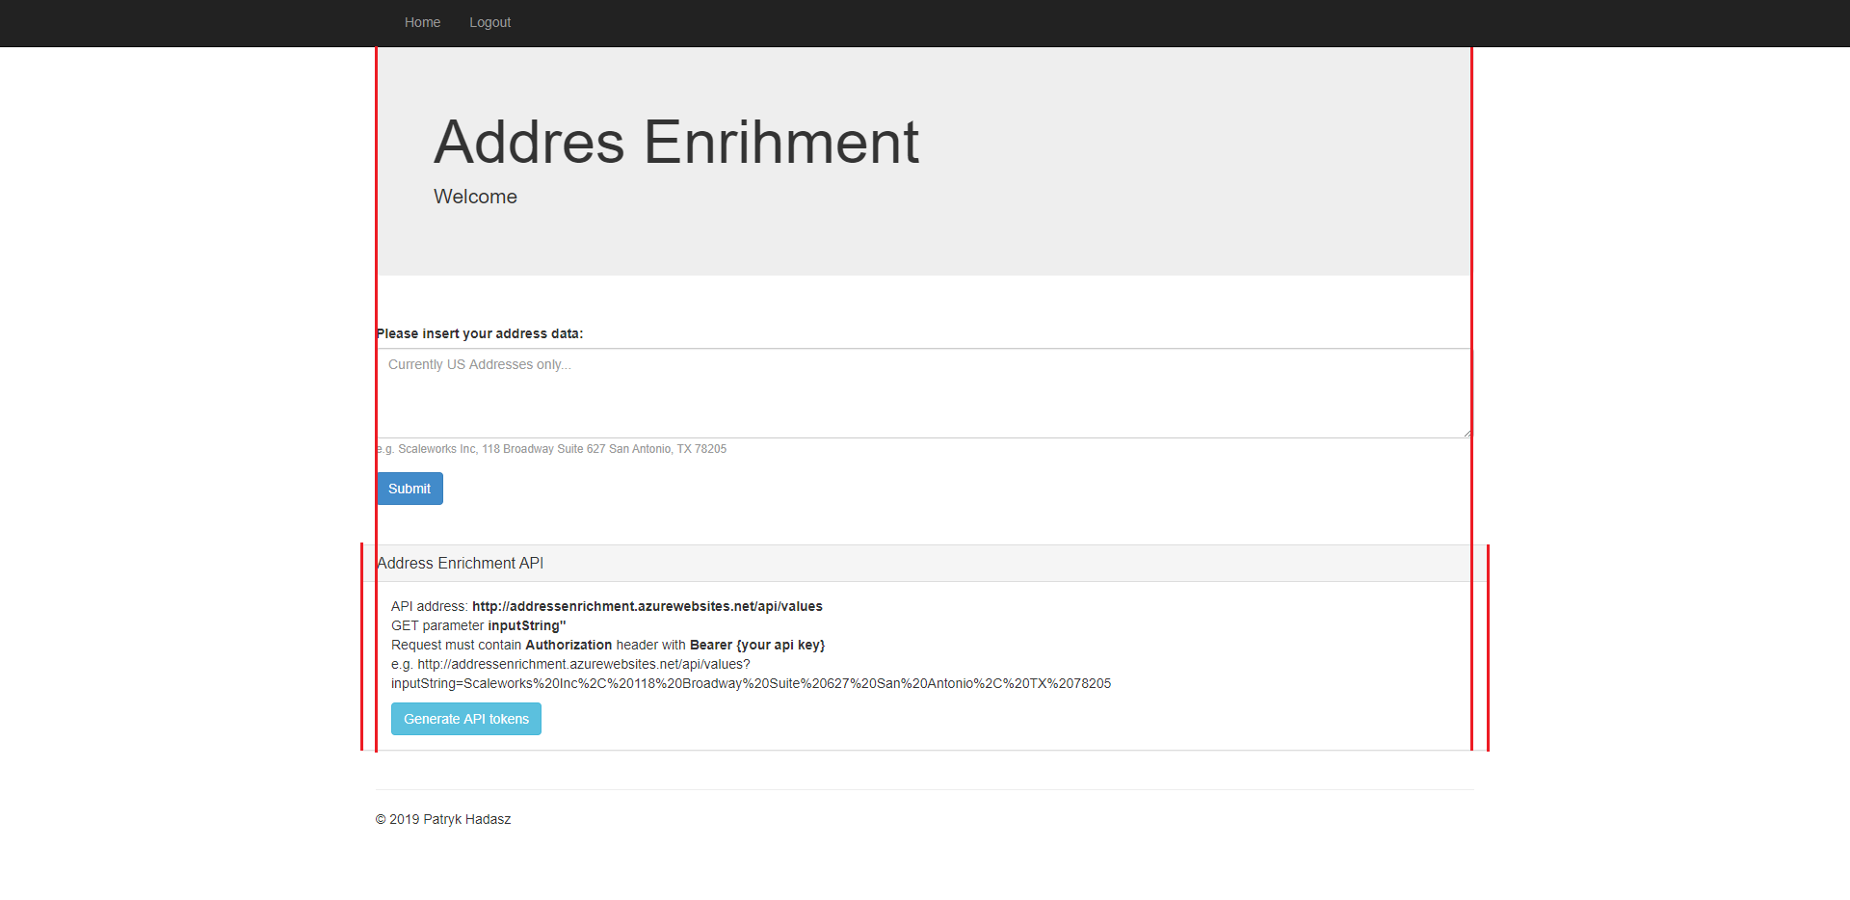

|  |  |
| --- | --- |
| **ID** | 1003 |
| **Name** | Login Page – no margin for error |
| **Priority** | P3 |
| **Steps to reproduce**:   1. Log into the system with email address not in @delivered.io domain   **Expected results**:   * Error message has been displayed and contains margins as the rest content on page   **Actual results**:   * Error message has been displayed and doesn’t contain left and right margins   **Please take a look at the attached screenshot.** | |

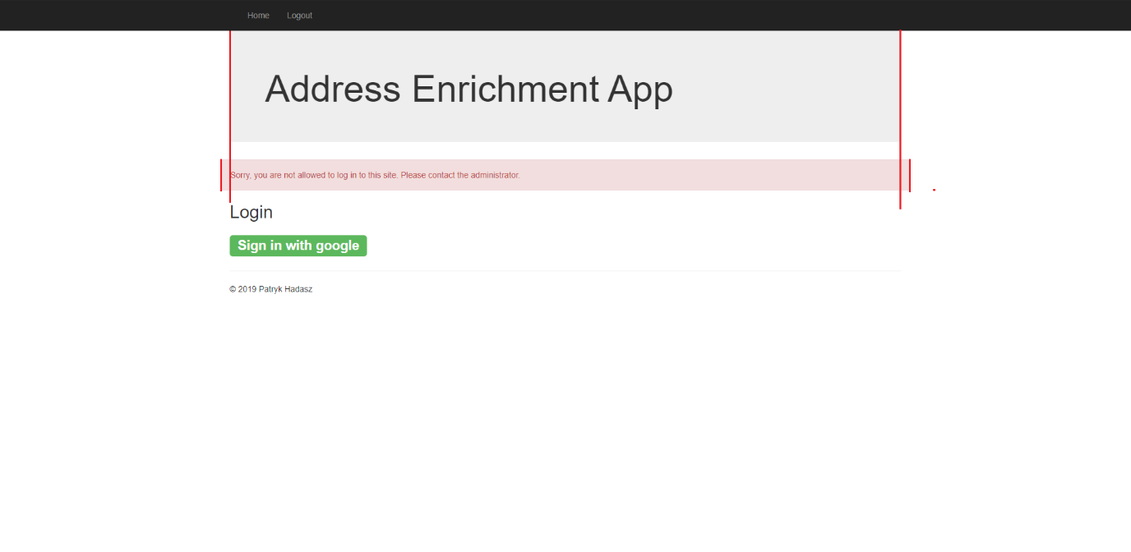

|  |  |
| --- | --- |
| **ID** | 1004 |
| **Name** | Home Page – welcome text doesn’t contain space |
| **Priority** | P3 |
| **Steps to reproduce**:   1. Log into the system 2. Open Home Page   **Expected results**:   * Header contains text ‘Welcome {FirstName} {LastName}’   **Actual results**:   * Header contains text ‘Welcome {FirstName}{LastName}’ (without space char between names)   **Please take a look at the attached screenshot.** | |

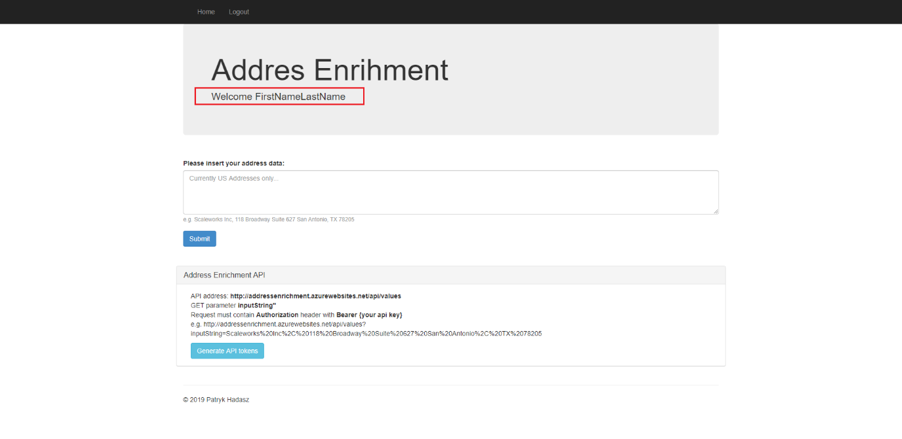

|  |  |
| --- | --- |
| **ID** | 1005 |
| **Name** | Google authentication has default mail |
| **Priority** | P2 |
| **Steps to reproduce**:   1. Open Login Page 2. Click on the ‘Sign in with google’ button   **Expected results**:   * Google authentication page with empty email address input has been opened   **Actual results**:   * Google authentication page with default value (‘HadaszPatryk@gmail.com’) for email address input has been opened   **Please take a look at the attached screenshot.** | |

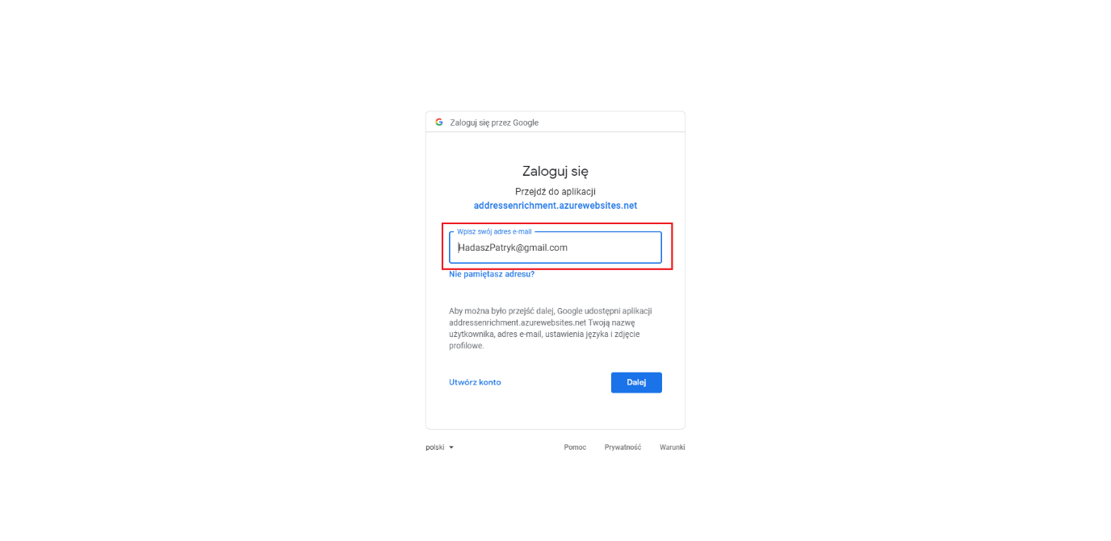

|  |  |
| --- | --- |
| **ID** | 1006 |
| **Name** | Email in not @delivered.io domain is authorized |
| **Priority** | P0 |
| **Steps to reproduce**:   1. Open Login Page 2. Click on the ‘Sign in with google’ button 3. Log into the system with email not in ‘@delivered.io’ domain 4. Click Home link on the top navbar   **Expected results**:   * Home Page has not been opened (user not authenticated correctly)   **Actual results**:   * Home Page has been opened – user has been authorized   **Please take a look at the attached screenshots.** | |

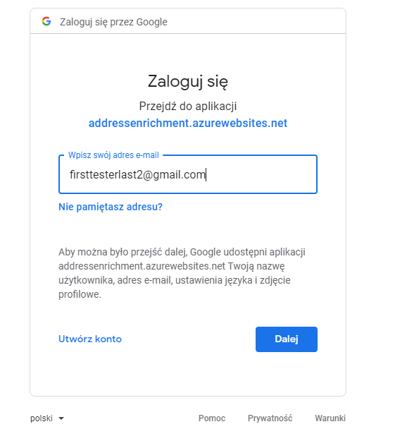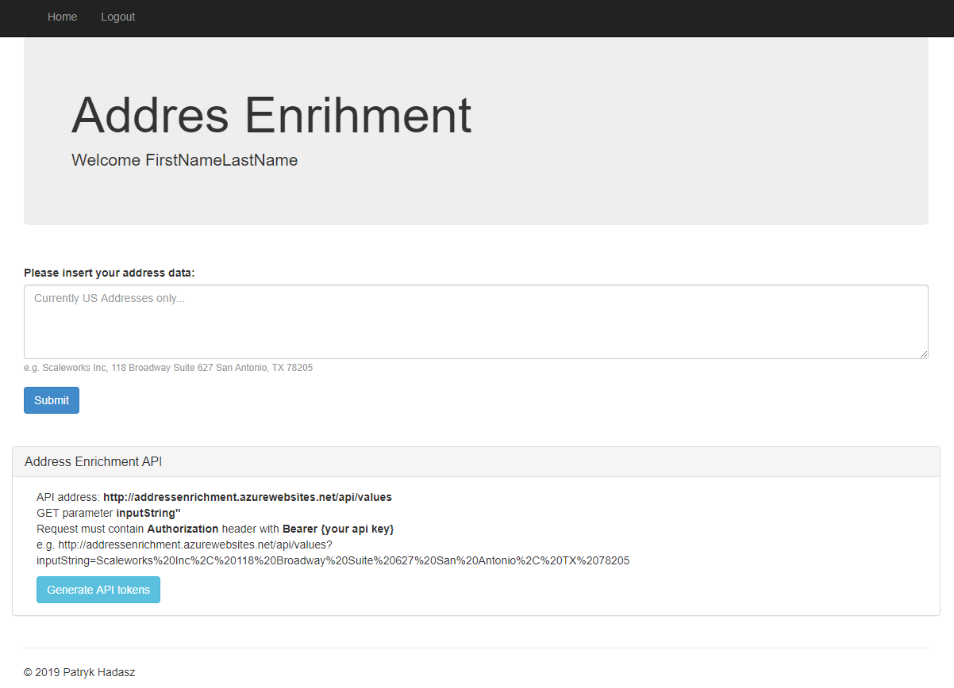

|  |  |
| --- | --- |
| **ID** | 1007 |
| **Name** | Empty address data request returns strange text |
| **Priority** | P2 |
| **Steps to reproduce**:   1. Log into the system 2. Open Home Page 3. Leave Address Data input empty 4. Click on the ‘Submit’ button   **Expected results**:   * Proper information for end user has been displayed   **Actual results**:   * Returned text: ‘[object Object]’   **Please take a look at the attached screenshots.** | |

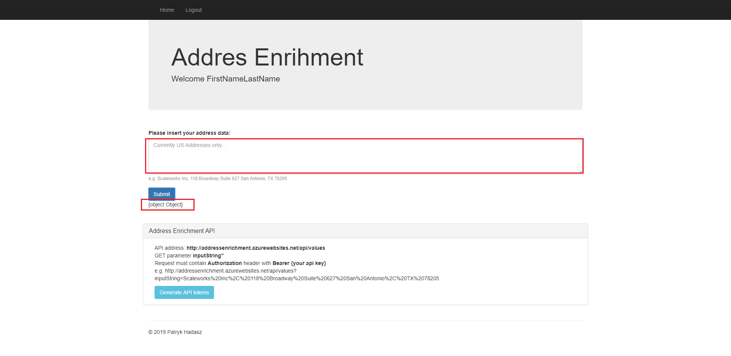

|  |  |
| --- | --- |
| **ID** | 1008 |
| **Name** | User can get to home page without authentication |
| **Priority** | P0 |
| **Steps to reproduce**:   1. Open Login Page 2. Click Home link on the top navbar   **Expected results**:   * Home page has not been opened without authentication   **Actual results**:   * Home page has been opened   **Please take a look at the attached screenshots.** | |

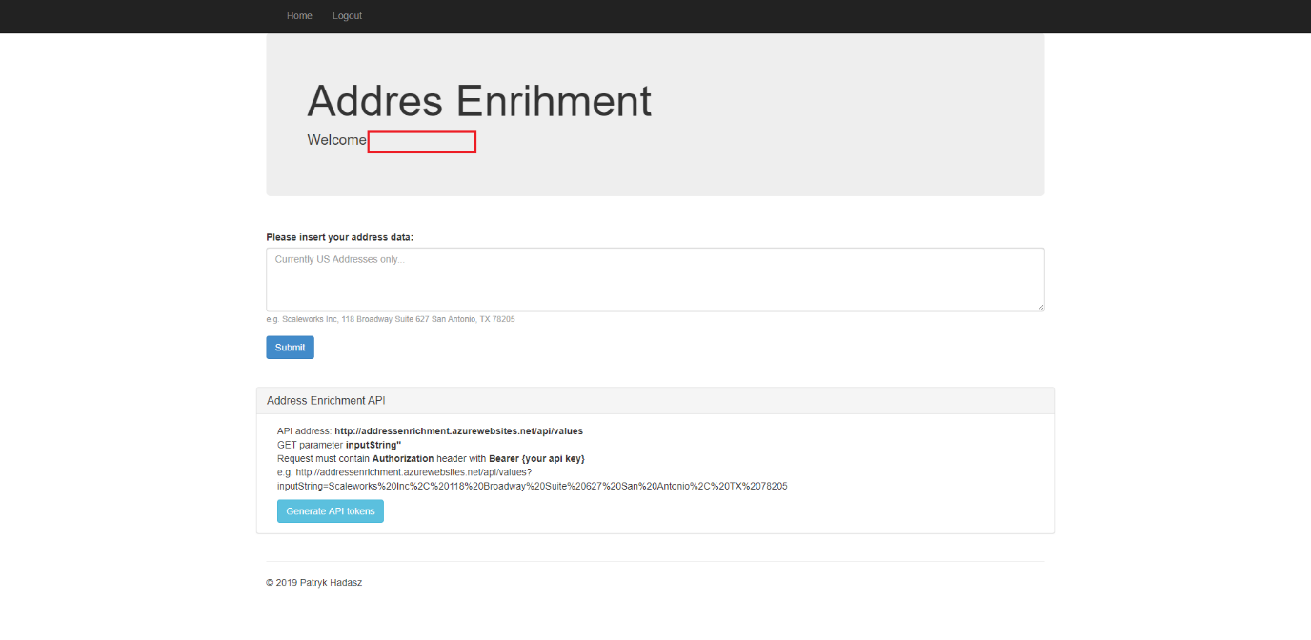

|  |  |
| --- | --- |
| **ID** | 1009 |
| **Name** | Logout link is visible withot logging to the system |
| **Priority** | P2 |
| **Steps to reproduce**:   1. Open Login Page (without logging into the system)   **Expected results**:   * ‘Logout’ link is not visible on the navbar   **Actual results**:   * ‘Logout’ link is visible without logging into the system (and directs user to login page)   **Please take a look at the attached screenshots.** | |

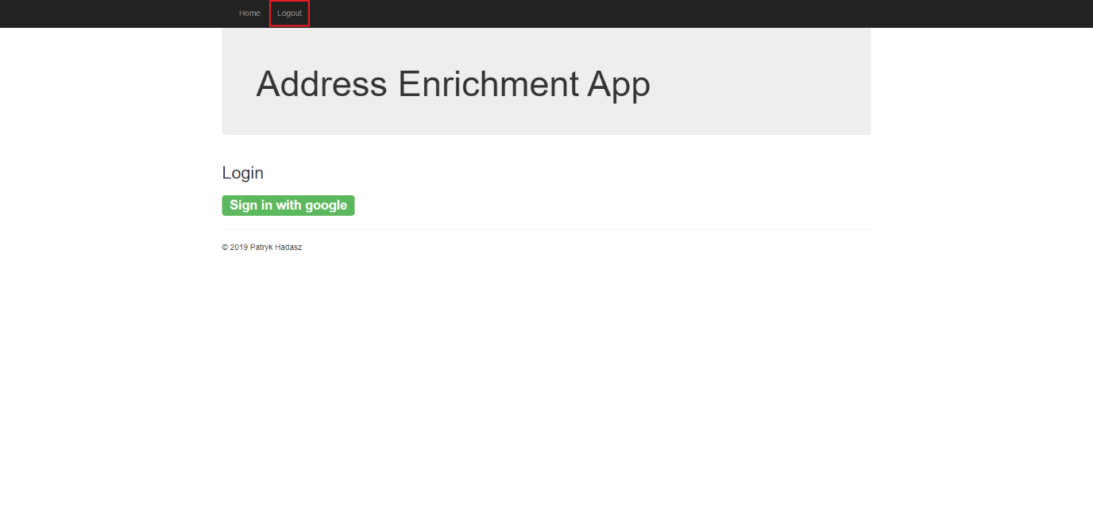

|  |  |
| --- | --- |
| **ID** | 1010 |
| **Name** | API Access Token text goes out of the window |
| **Priority** | P3 |
| **Steps to reproduce**:   1. Log into the system 2. Open Home Page 3. Click ‘Generate API tokens’ button (repeat this step until actual results are reached)   **Expected results**:   * Generated Access token text is inside ‘Address Enrichment API’ window   **Actual results**:   * Generated Acess token text goes out of the ‘Addess Enrichment API’ window   **Please take a look at the attached screenshots.** | |

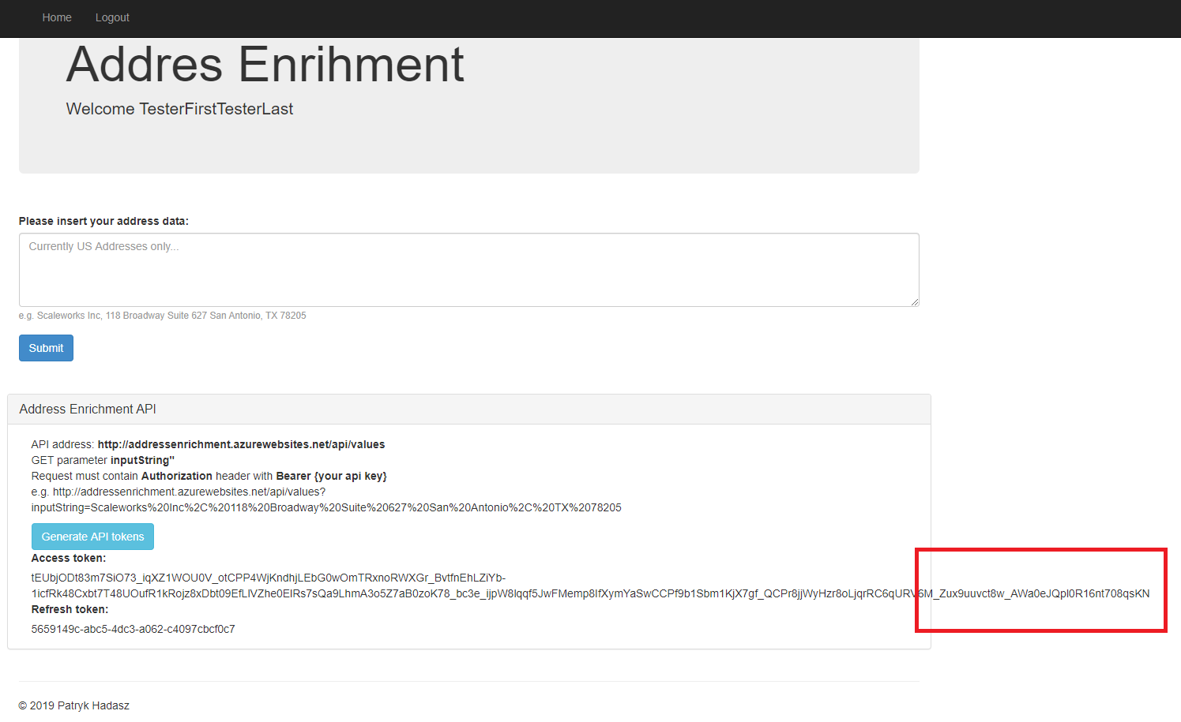

Suggestions

* Title for pages should be consistent. E.g. currently home page contains title = ‘Address Enrichment’, while login page contains title = ‘Address Enrichment App’
* On the login page, in button text ‘Sign in with google’, Google should be started with capital letter as it’s the name of company
* API contains one parameter named ‘inputString’. I think we should change this name to something more intuitive like ‘addressData’. We can also create to separated parameters – one for name and one for address
* API should inform about and expose a way to generate Access token/Refresh token by request (for using as third party and for testing purposes)
* It would be a good practice to add some identifiers at least for the most imporant HTML elements on each page during development (attribute ‘id’ would be the best option)